Create a GitHub account. You will need it for the course. Link: <https://github.com/>

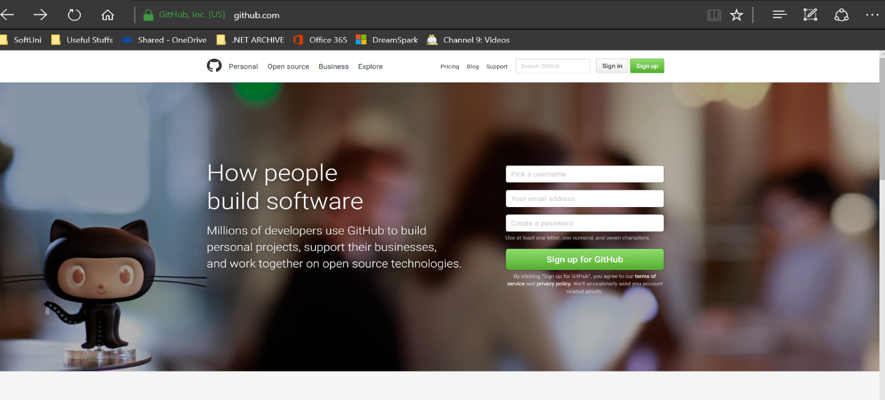

After you verify your account by e-mail you are ready to go. On your profile page search for Repositories.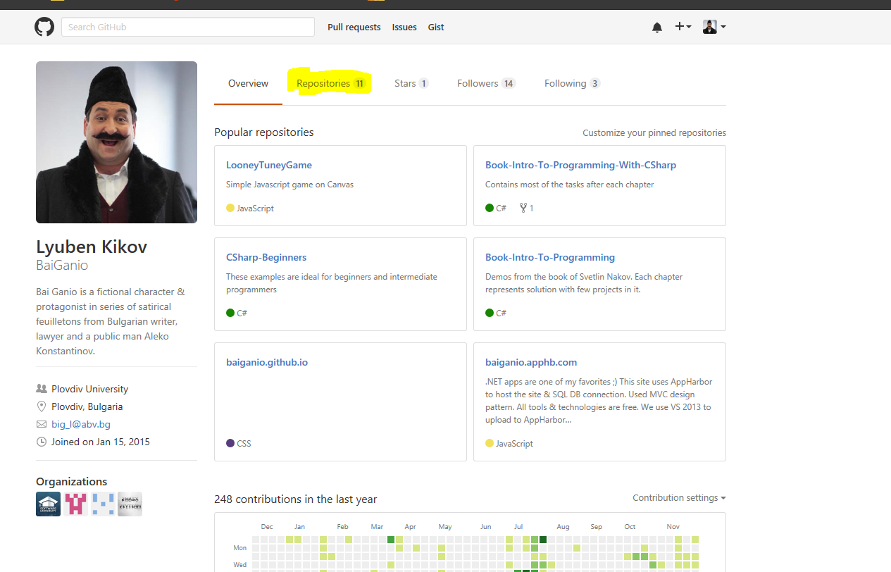

Find the button and create new repo.

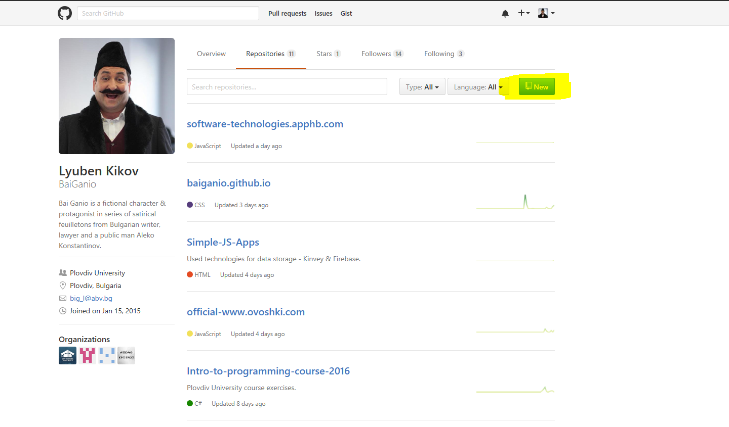

Follow the steps to create your repository.

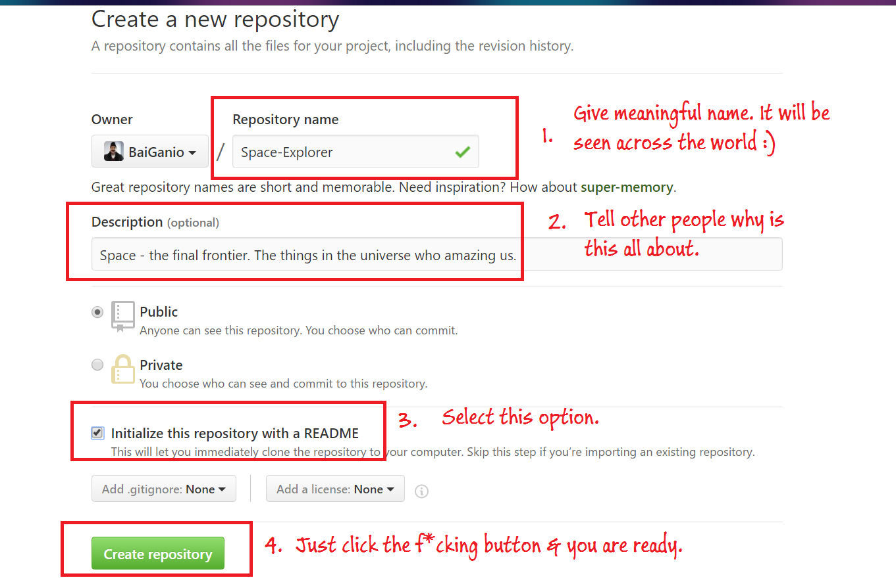

Now the key point is to find Windows 10 tool called PowerShell console. This will allow us to execute ‘git’ commands without any other 3rd party installations.

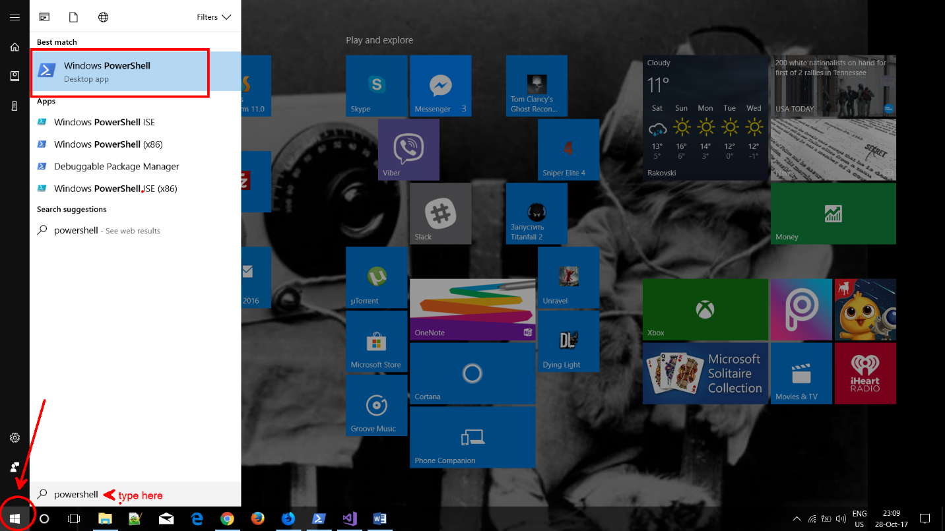

First thing which you need to notice is that the current directory in which we are is where .exe file of the PowerShell program is placed – this directory is not the one we need. In our example we need a directory where we will store our project. Further this project will be ‘push’-ed and stored to the GitHub repository. Keep in mind that we need to make a difference between the ‘git’ commands and ‘regular’ one. Also you’ll need to execute some commands which for simplicity are stored in a text file. Make sure you are familiar with it before going any further.

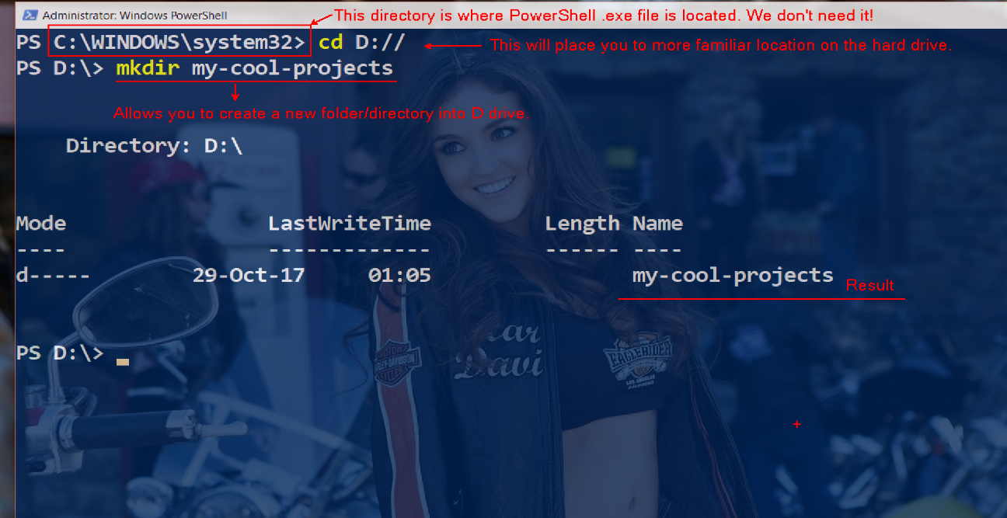

You need to do one more switching of directories. Execute ‘cd my-cool-projects’. We need to be in this directory when we dealing with Space-Explorer GitHub repository. Next one is to copy the repository url, which is provided on the page of your repo. Simply copy it.

Exce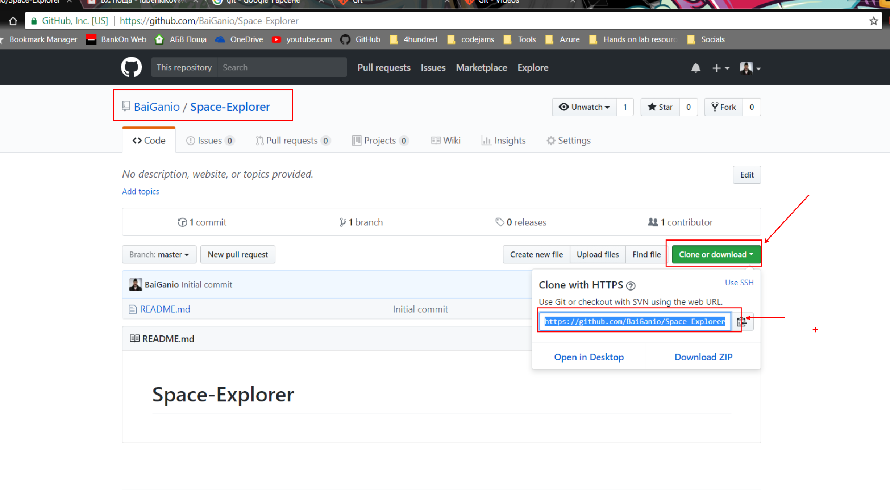

Execute the following command in the console and you will see your Space-Explorer folder downloaded in my-cool-projects folder. You might be prompt for your GitHub username and password.

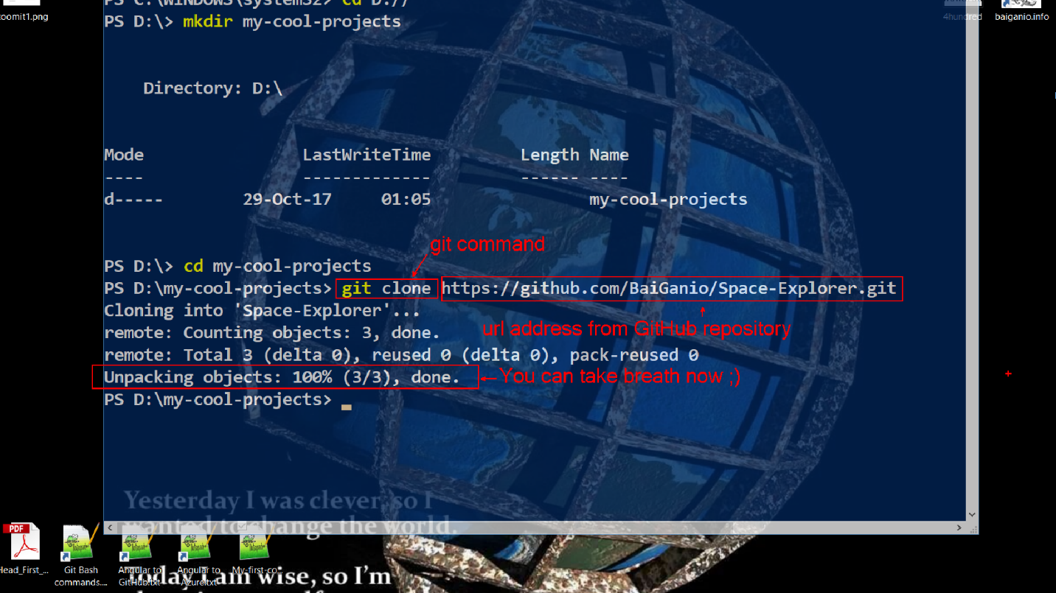

Now you can create any kind of files in this Space-Explorer directory. Don’t delete any files which comes with the download or you might cause a problems pushing your files to the GitHub repository.

In our example we will create a simple C# console application using Visual Studio 2017 Community. Make sure that you point your VS project to the Space-Explorer folder!

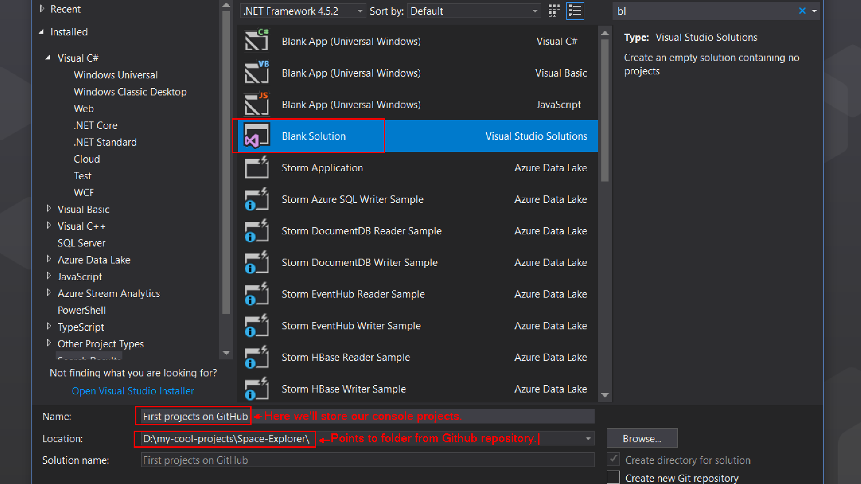

Create your project. Run it and make sure your code works. Never push to the repository code which is broken. This is a bad habit!

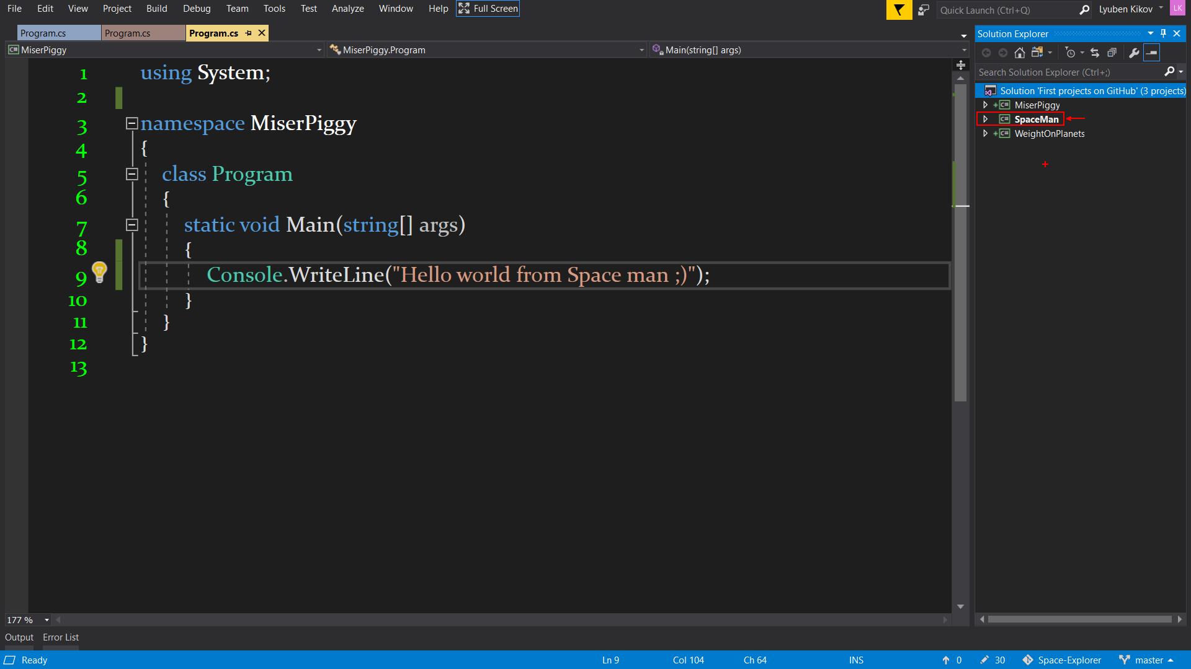

Now it’s time for the fun part. We will ‘push’ our code to the GitHub repo. This will allow us to store, save, refactor, share our code with the world. Imagine you are in an exam and you want to help you friend. What better way to share you code with few commands. This will locate your work instantly on the web in your GitHub repo and will be available to the world… or at least to this which have the repo url ;). It can be seen by anyone. Cool, uh? ☺

Before we continue – we should do a ‘regular’ command on the console. We want to switch to Space-Explorer directory. Keep in mind that we want to manage only the projects which are created in this particular directory. This will allow us to execute ‘git’ commands which are related to our repo on GitHub. Git commands will take care of our newly created files in the directory. Will manage them and help us to ‘push’ our work to our Github repo.

Notice that they are execute in order. If you skip any step you’ll get an error message. Make sure you are familiar with the commands from the text file.

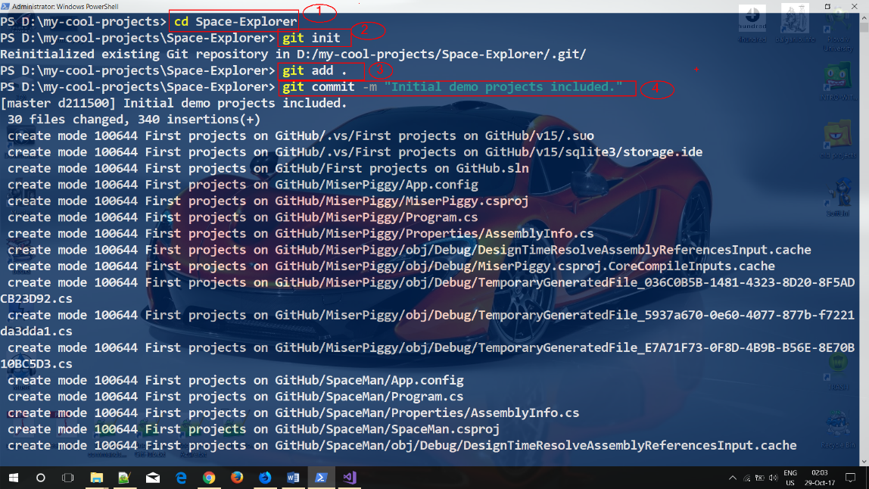

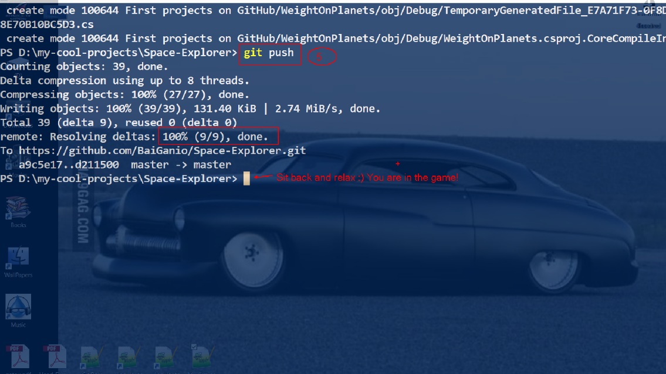

If everything goes well, after refreshing repo page on GitHub we should see our projects ‘push’-ed. Notice that all files and folders in your local solution matches with GitHub folder tree. The web UI is more user friendly for managing projects across the team than the console/terminal one, but keep in mind that both approaches for managing files should be used in ‘combo’. This will give us simplicity and speed.

